REFERENCE FOR FILLING IN APPLICATION
on changes to the State Register of Individuals – Taxpayers
(submission in electronic form)

Attention! Submission of Application in electronic form is possible on the basis of birth certificate for minors (up to 14 years) or passport of citizen of Ukraine

Fill in the Application in Ukrainian language
Enter registration number of the taxpayer’s account card, in which changes are made to the corresponding field

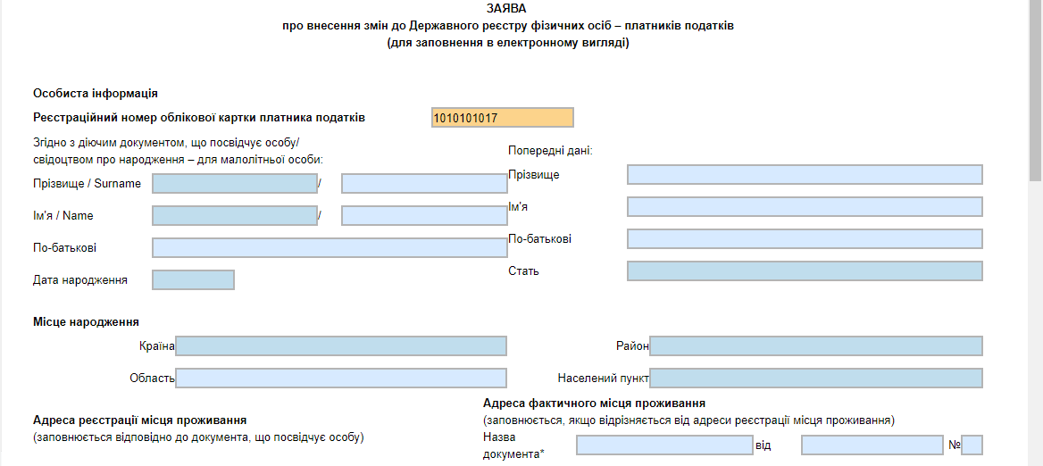

Fill in the fields “Surname”, “Name” and “Patronymic” according to the identity document (for a child according to the birth certificate). Use selection of data from the directory to fill in each field
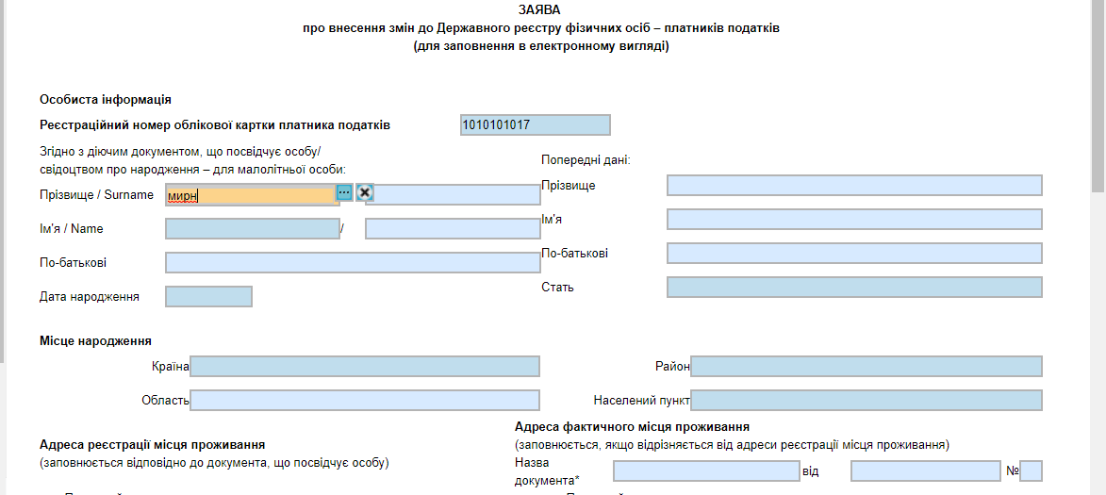
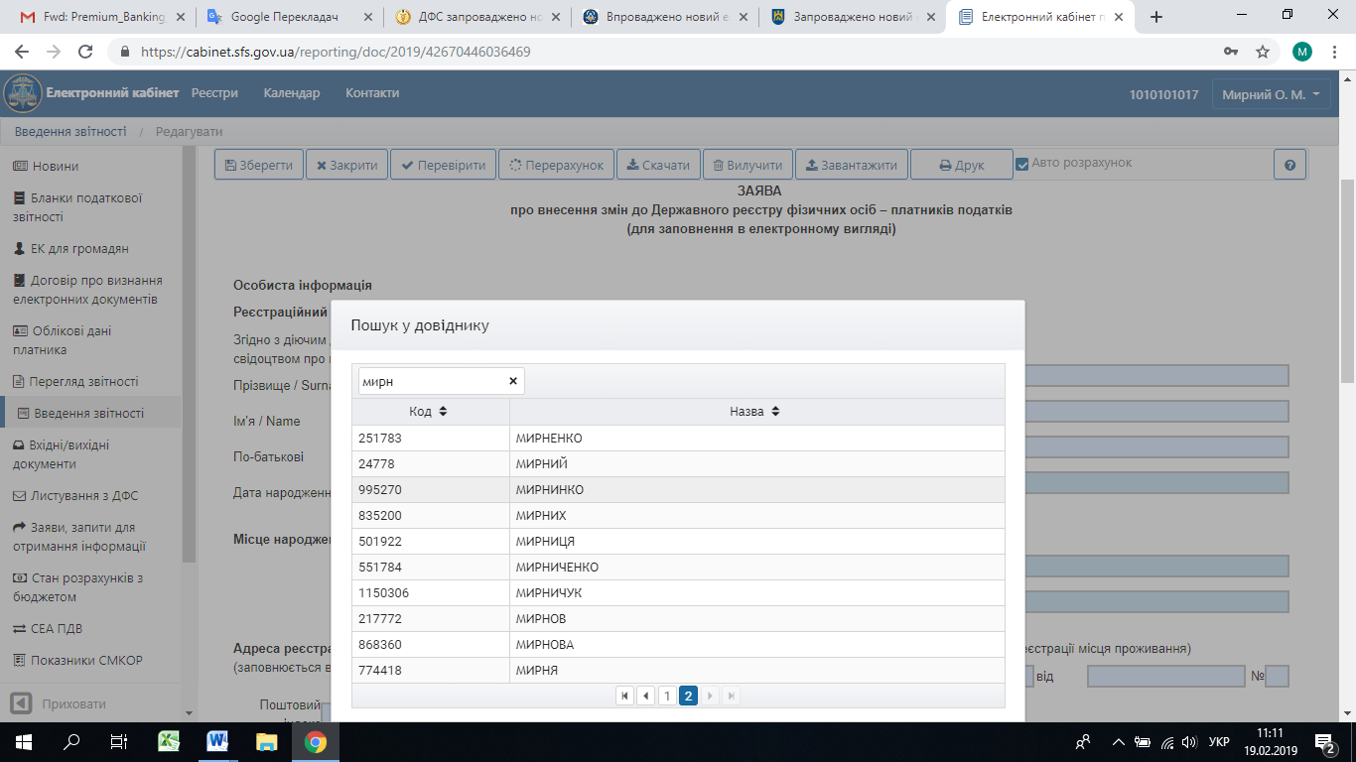
In the absence of specific last name, first name or patronymic in the directory, it is needed to enter data manually and carefully comparing spelling according to the identity document. System allows saving and sending form in the presence of non-critical remarks such as absence of certain data in the directory
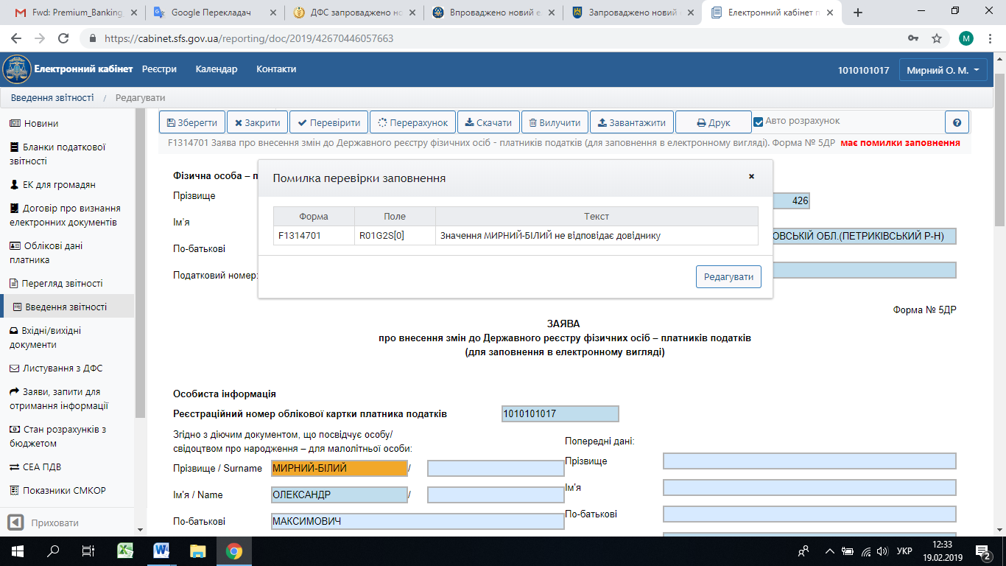

If identity document specifies information about the individual’s surname and name in Latin letters, fill in the fields “Surname” and “Name” through a slash in Latin letters
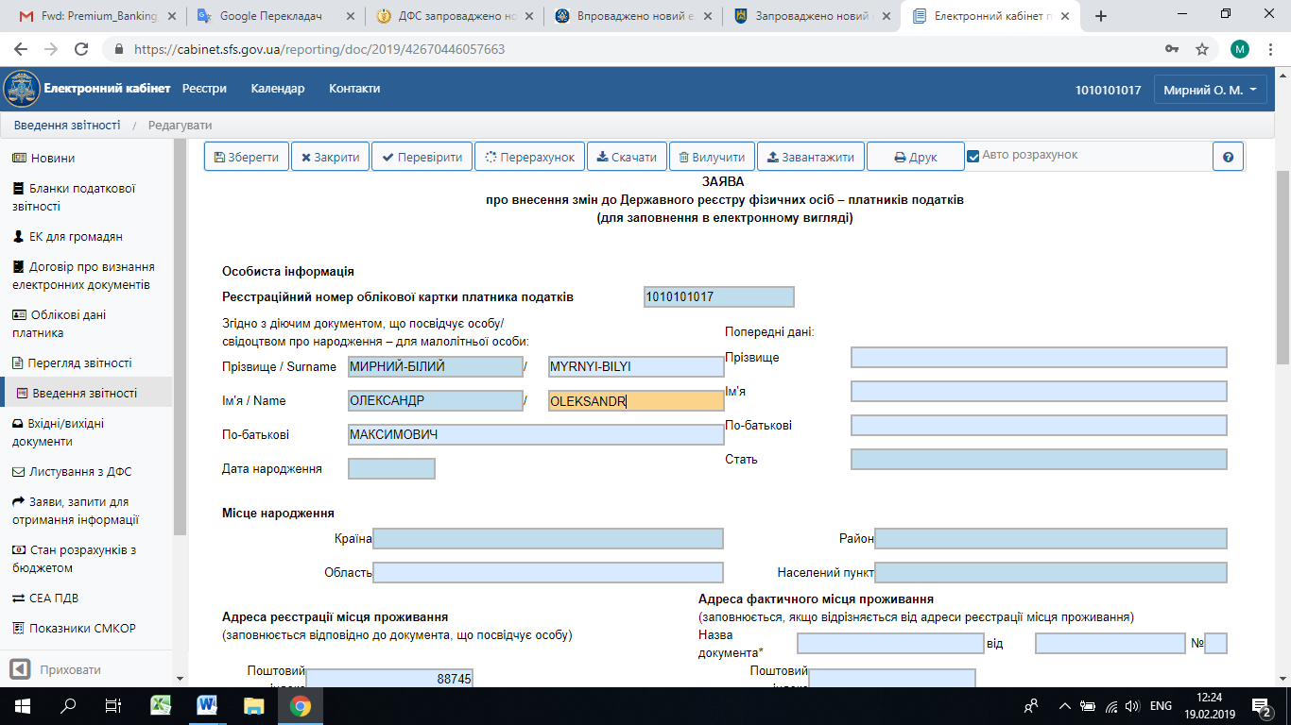

If there were changes in last name, first name and / or patronymic, enter previous data of the last name, first name and / or patronymic in appropriate fields of the form 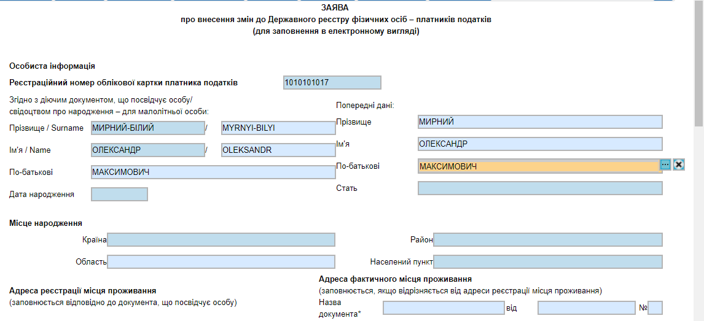

Enter date of birth according to the identity document (for a child according to the birth certificate): number – 15, month – 03, year – 1992. Filling in, it is possible to use calendar or enter appropriate date in the field manually 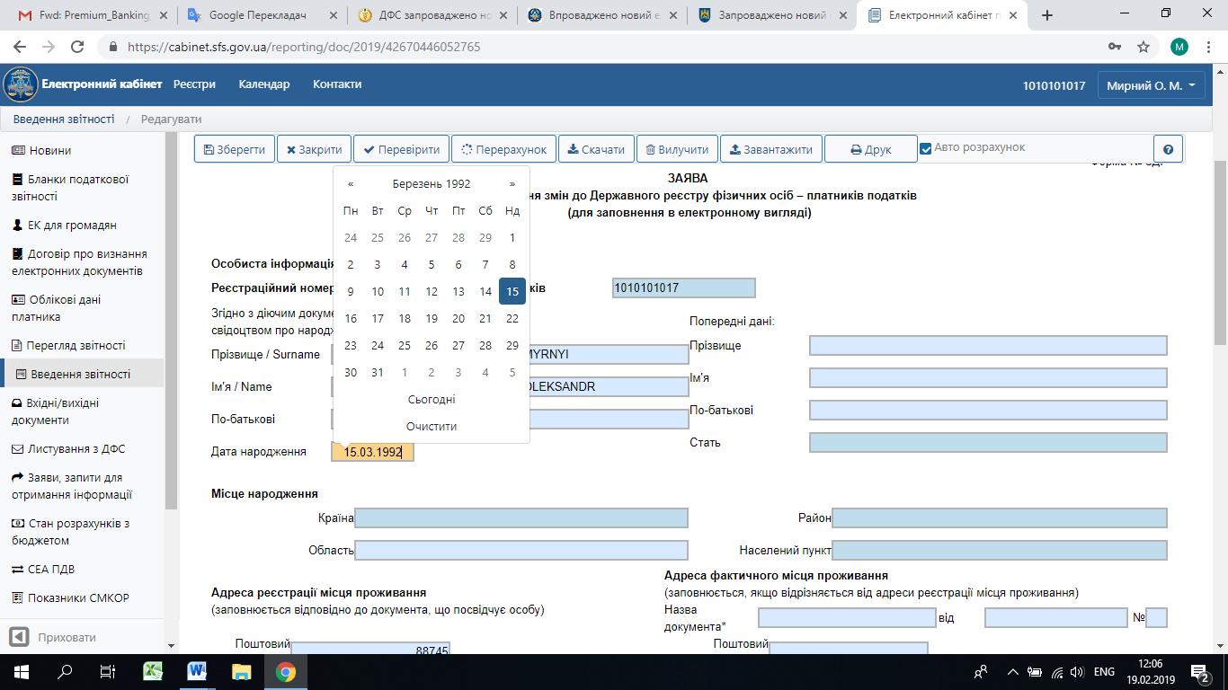

Select male or female in the “Gender” field
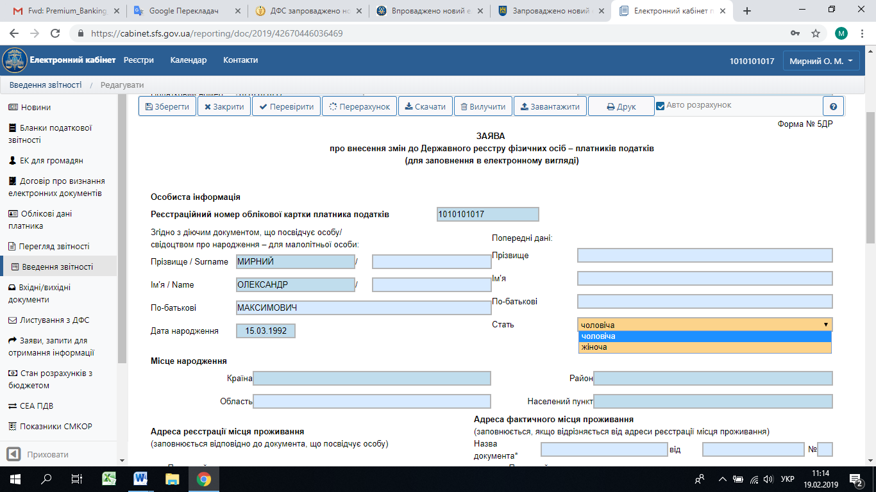

Place of birth is filled in according to data of the identity document (for a child according to data of the birth certificate). Use the selection of data from the directory to fill in
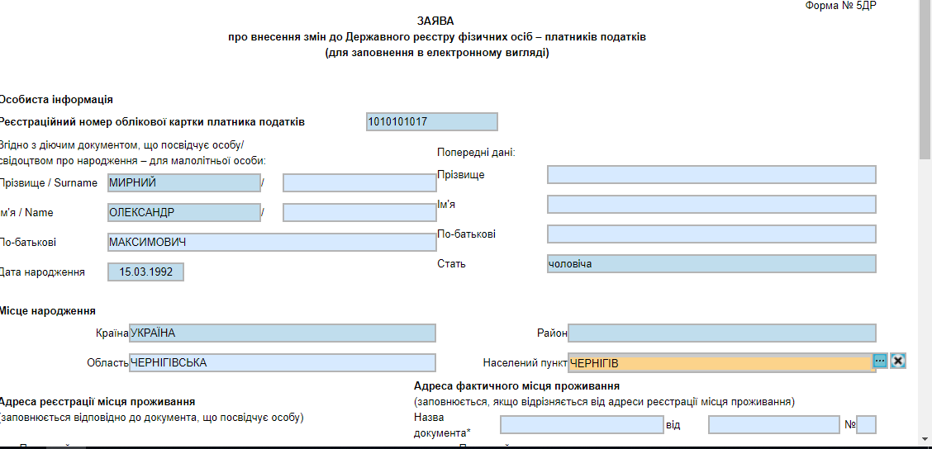

Similarly, use directories to fill in the address of residence registration according to the identity document, certificate of residence registration / stay or other documents that include information about residence registration

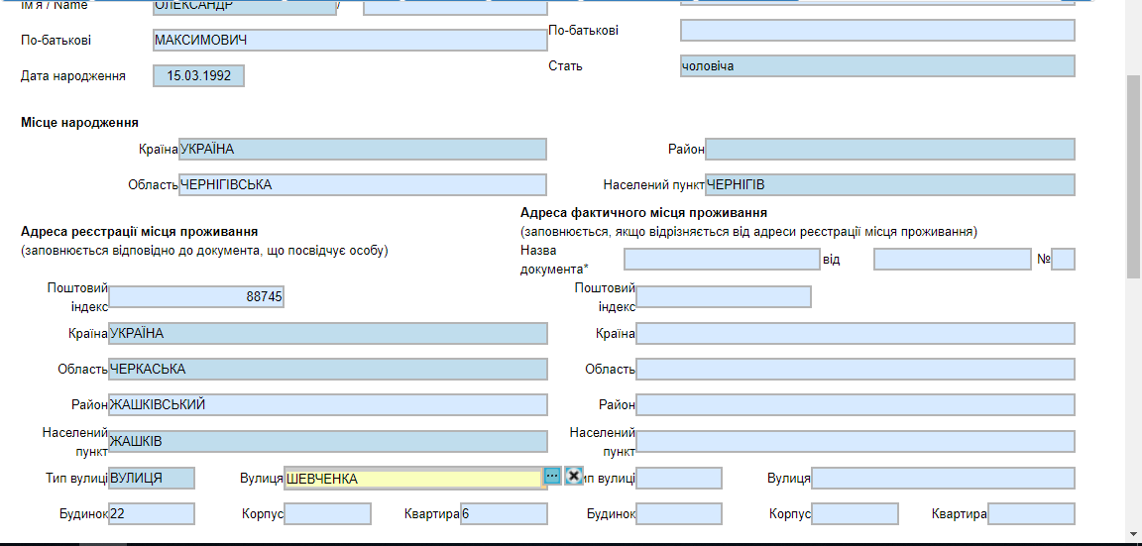
For cities with district distribution, such as Kyiv, Kharkiv, Dnipro, Odessa, Mariupol, etc., it is necessary to enter certain district of city manually in the “District” field. The “Area” field in “Residence registration address” section must be filled in. Title of district of Kyiv city must be entered, for example, “Pecherskyi”, “Holosiivskyi” (Kyiv has ten districts in total). An error of not having specific district in the directory is not critical, as system you to save and send the form
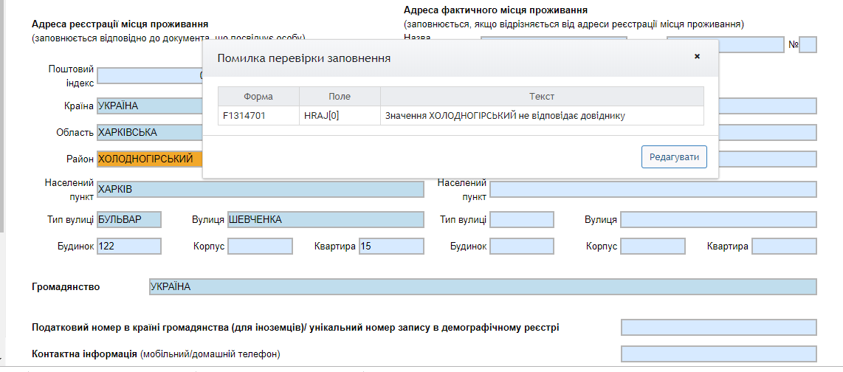
Fill in address of actual residence if such address differs from the address of residence registration (on the basis of relevant document, for example: registration certificates of internally displaced persons; certificates confirming the whereabouts of Ukrainian citizens living in the temporarily occupied territory or relocated from it)
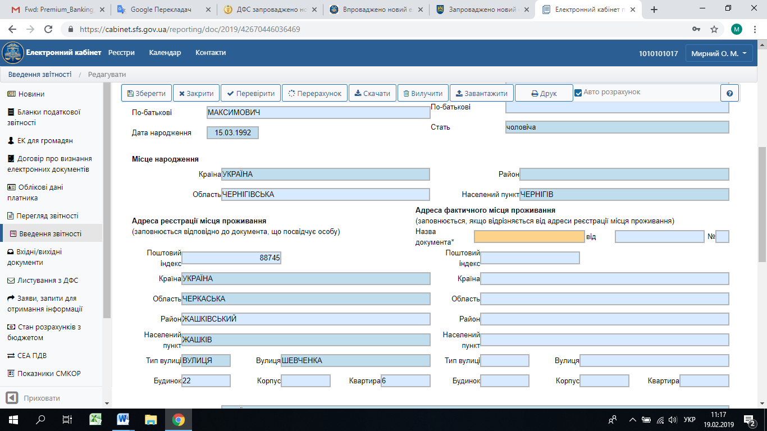
Enter name of citizenship country in the “Citizenship” column
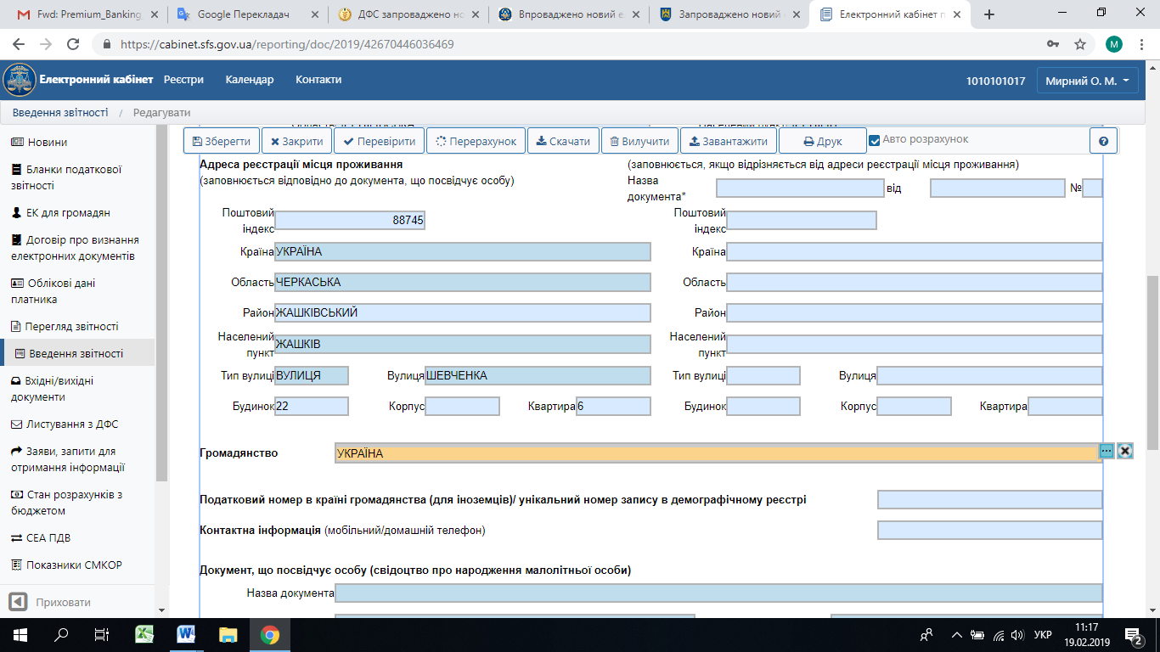
Indicate your mobile or home phone in the “Contact information” column
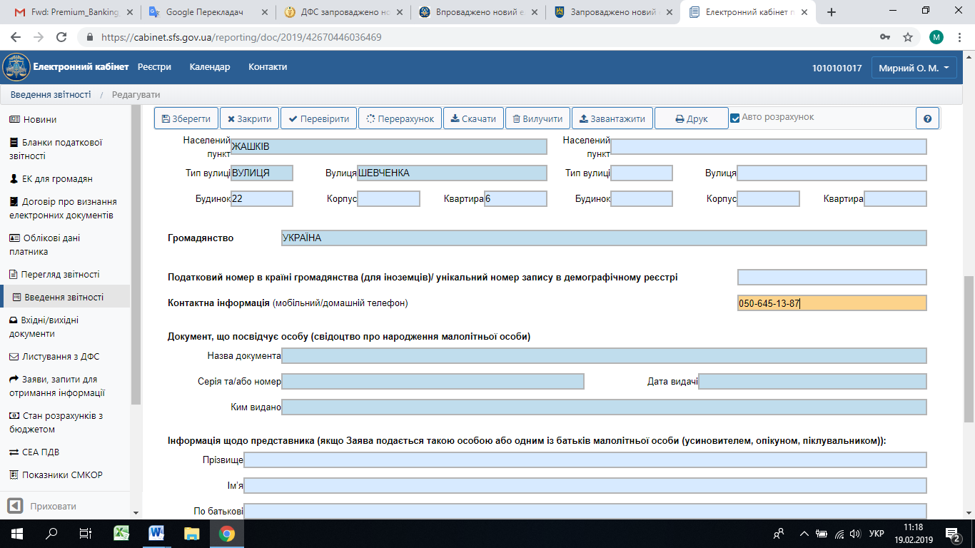
Specify requisites of the identity document or birth certificate of a minor, its title, series (if any), number, issuance date and authority that issued document in the “Identity document” section
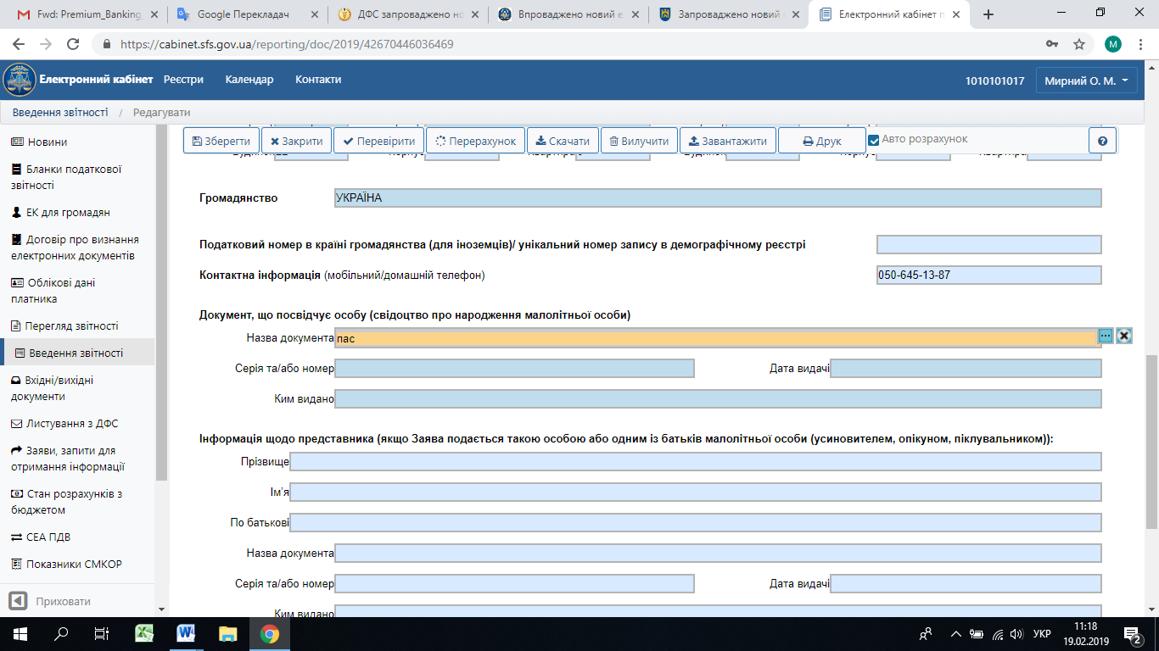
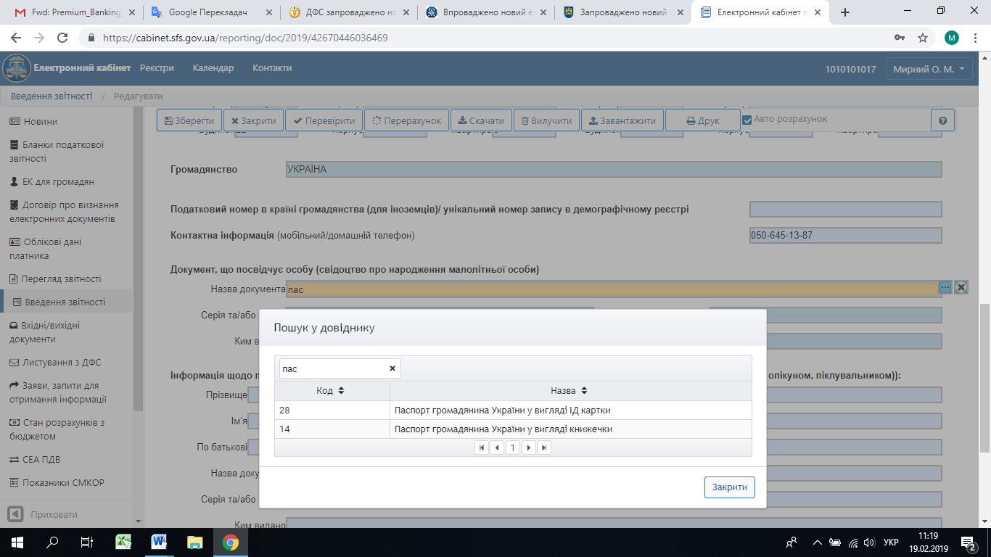
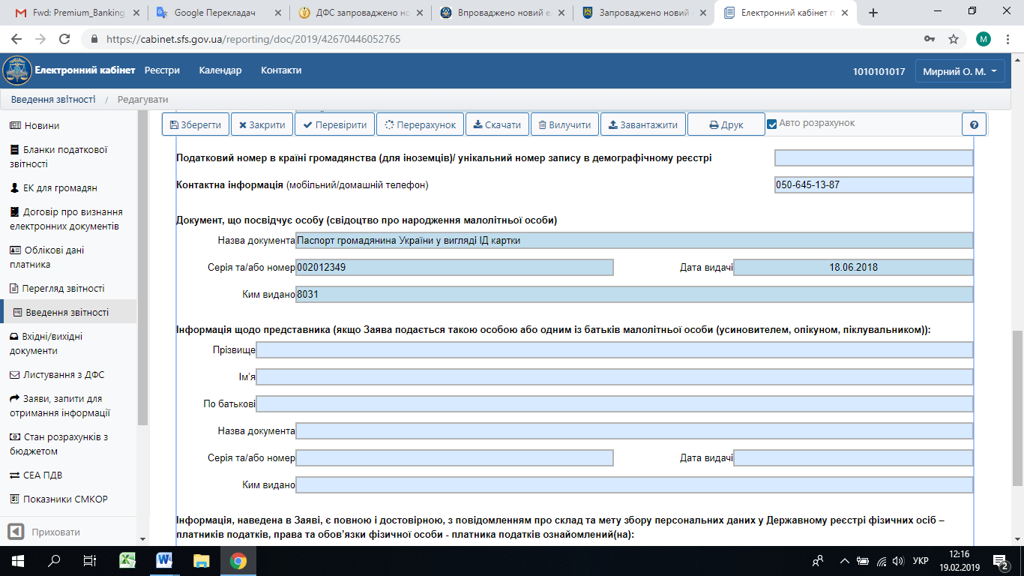

If Application is submitted by representative or one of minor’s parents (adoptive parent, guardian, trustee), the registration data and data of document certifying such a person is indicated

Enter date of filling in the Application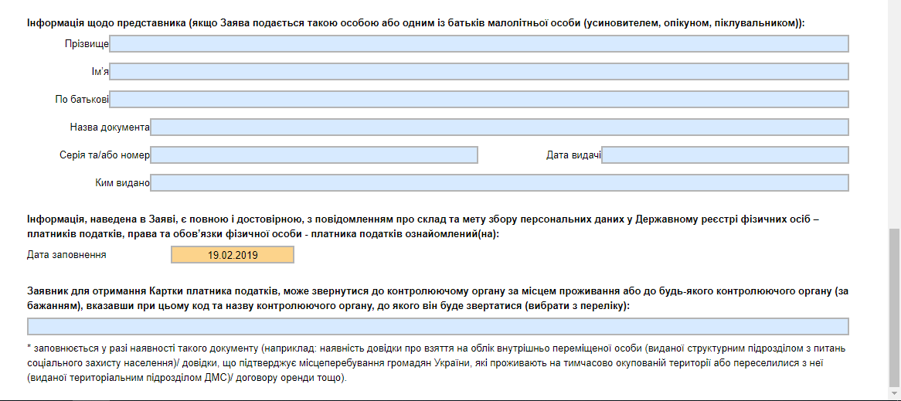

Select the Taxpayer Service Center where you want to obtain document certifying registration in the State Register of Individuals – Taxpayers (Taxpayer Card)
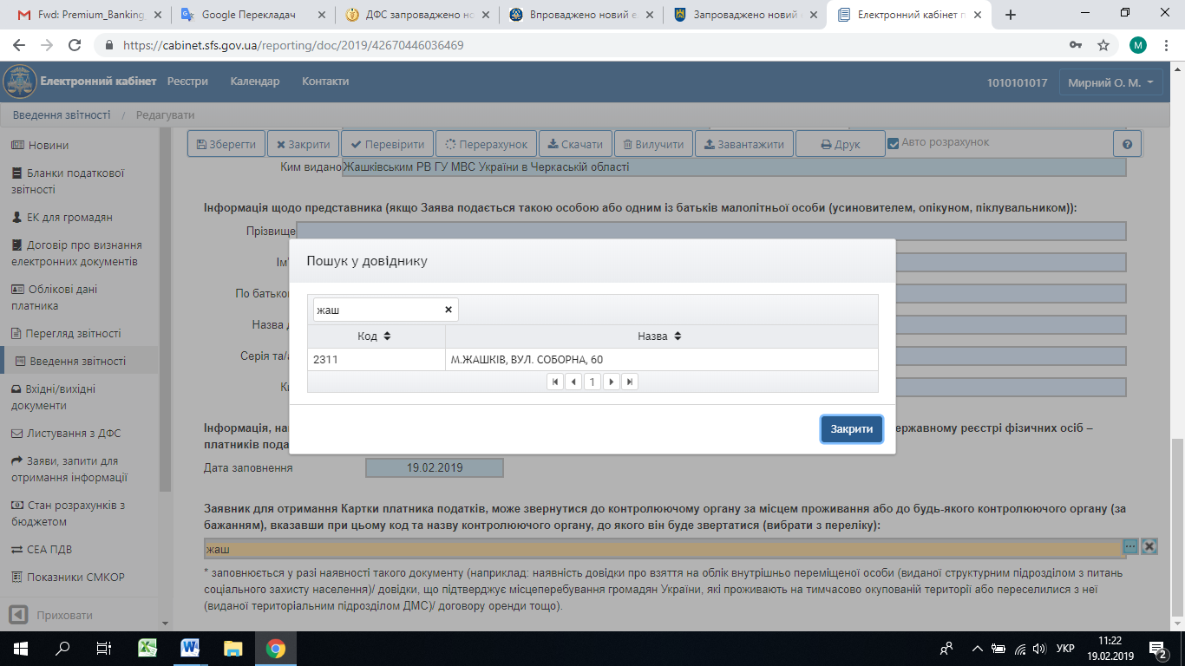

The following will be sent in response:
Receipt №1 – Notification on the acceptance of request;
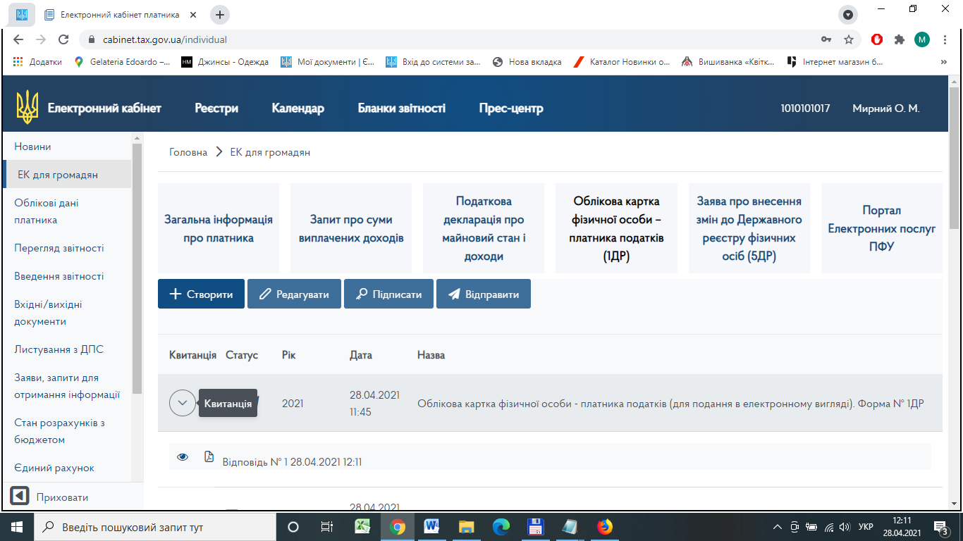

Receipt №2 – Notification form F1414701 on the processing results.
